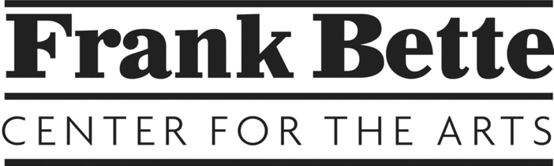
Prospectus: Luminous

Main Gallery: June 6 - August 1 2025
Luminous: Giving off light; brilliant, radiant, clear, distinct. Implies steady, glowing light by reflection in surrounding darkness. A positive adjective when describing something that does not literally glow; such as a face, performance, or a poem. Opposite: dark, lackluster, obscure, insignificant.

Intake: Sunday, June 1. 11am-5pm.
Exhibit opens: Friday, June 6.
Opening reception: Saturday, June 14, 3-5pm
Mid-show reception: Saturday, July 12, 3-5pm.
Exhibit ends: Friday, August 1.
Pickup: Sunday, Aug 3, 11am-5pm.

Who may apply?
Any artist may submit 2D, 3D and crafts for this exhibit. Content must be suitable for family viewing, including children.

How to submit:
Fill out the Inventory form, painting labels for 2D works and Artist Agreement Form. Bring these with the artworks to be submitted on receiving day, Sunday, June 1, 11am-5pm at the Frank Bette Center for the Arts, 1601 Paru St, Alameda, CA, 94501.

Entry Fees:
Members: $20 with unlimited entries.
Non-members $30 with a limit of 2 entries.
A list of possible volunteer activities will be available on receiving day and help is appreciated.

Artist Commissions: Artists receive 60% commission, FBCA 40%. Price your works to accommodate the commission rate. Artists are paid within four weeks of the close of the exhibit for any works sold. Please note that the center has a refund policy. Buyers may return purchased art for a full refund within 7 days of purchase with a receipt, assuming the art is in original condition.

Selection process:
Frank Bette Center for the Arts (FBCA) will select artwork based on how well the pieces fit with the theme and all works as a whole in the salon style exhibit. Please call the center at 510-523-6957 on Thursday June 5 if you have not already been notified of work that should be picked up. All non-selected works must be picked up by Friday Jan 24 as we do not have extra storage space.

Opening reception: Saturday June 14, 3-5 pm. Please bring individually wrapped snacks or a beverage to share. Invite your friends, clients and family to the party. Note that there is a mid-show reception July 12, 1-3pm.

Publicity
FBCA can do limited advertising. Postcards (hard copy) will be available and artists are expected to help distribute them to friends, family, and selected local businesses. Please help us advertise the show with your social media etc.

Pickup day
Please pick up unsold work at the end of the show on Sunday August 3, 11 am-5 pm.

If you are unable to pick up at this time, please make arrangements for someone to pick up your unsold works for you or work out arrangements with the gallery.

